**Assignment-8**

# Deploying a Project from Local Machine to GitHub and Vice Versa

**Overview**

Steps :

1. **Creating a GitHub repository**
2. **Generating a GitHub authentication token**
3. **Uploading files to GitHub using Git Bash**
4. **Cloning a repository to a local machine**

**Remark**: Git is an open-source version control system that tracks changes in source code. This process allows developers to manage and share their projects effectively.

# Step 1: Create a GitHub Repository

1. Go to [**GitHub**](https://github.com/)and sign in or create an account.
2. Click on the **GitHub logo** (top left).
3. Under **Top Repositories**, click **New**.
4. Enter a **Repository Name** (e.g., MCKV_AWS Lab).
5. Choose **Public** or **Private** (Here, we select **Private**).
6. Click **Create Repository**.

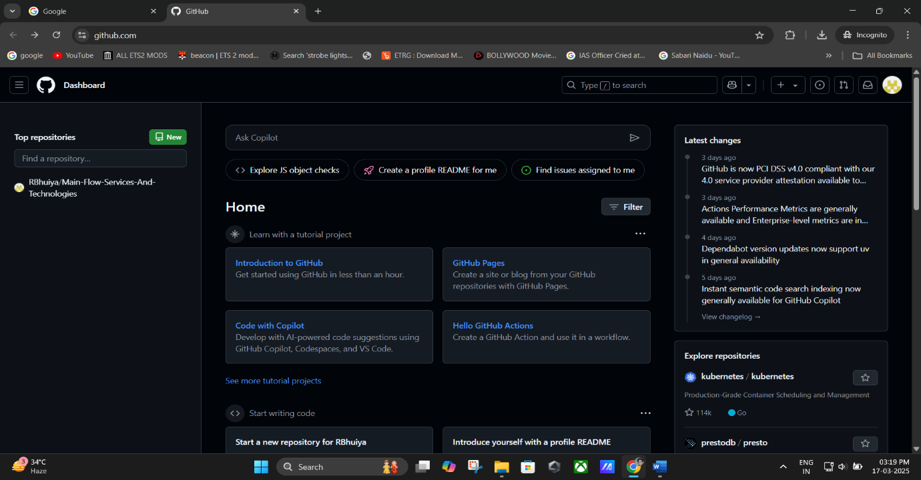

**(Login in to GitHub Console).**

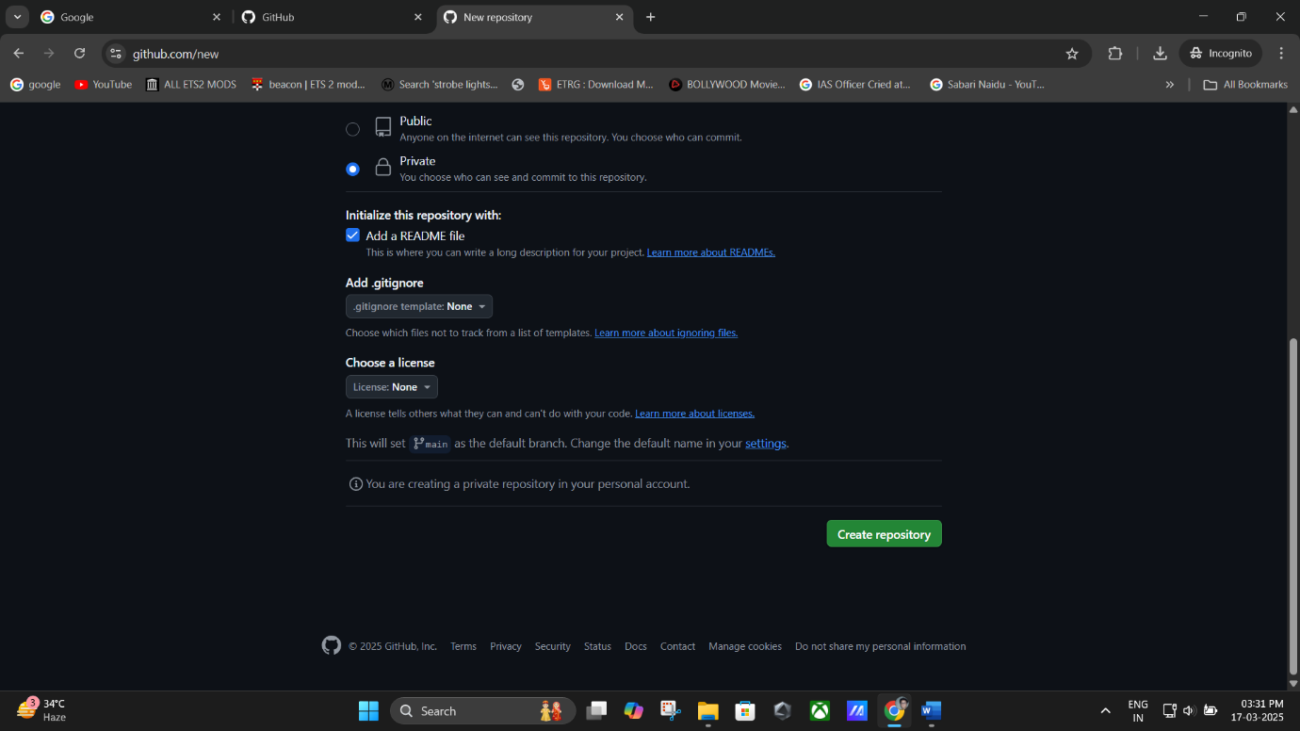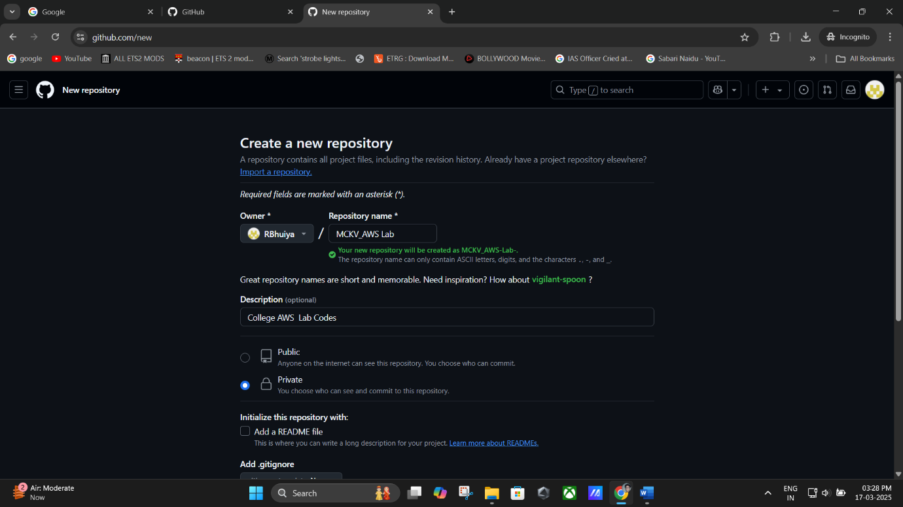

**(Creating new repository -> Private).**

**(Create: Creating repository).**

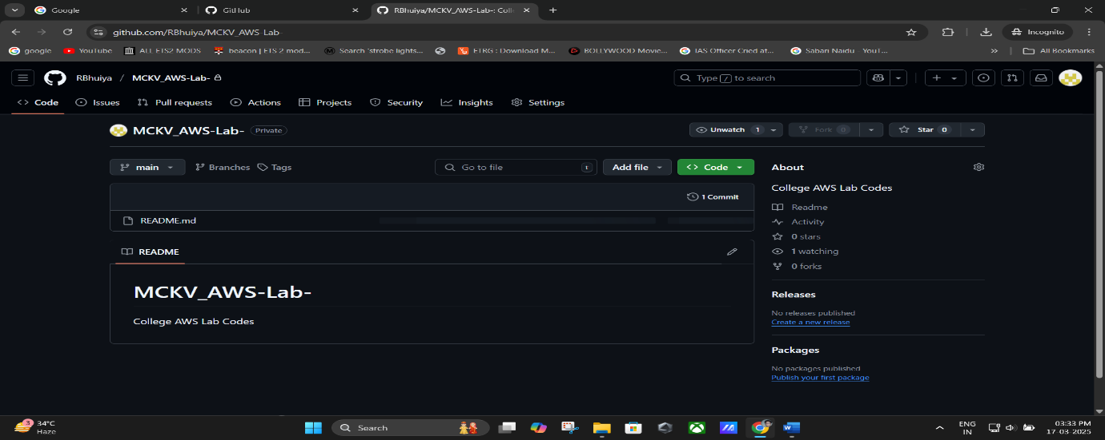

**Remark**: A repository is a storage location for project files and their revision history.

# Step 2: Generate a GitHub Authentication Token

GitHub authentication tokens are required for secure access without passwords.

1. Click on your **Profile Name** → **Settings**.
2. Go to **Developer Settings** (left sidebar).

### Click Tokens (Classic) → Generate New Token (Classic).

1. Enter a **Token Name** (e.g., tok1).
2. Set an **Expiration Period** (e.g., 90 days).
3. Check **all required permissions**.
4. Click **Generate Token** and **Copy the Token** for later use.

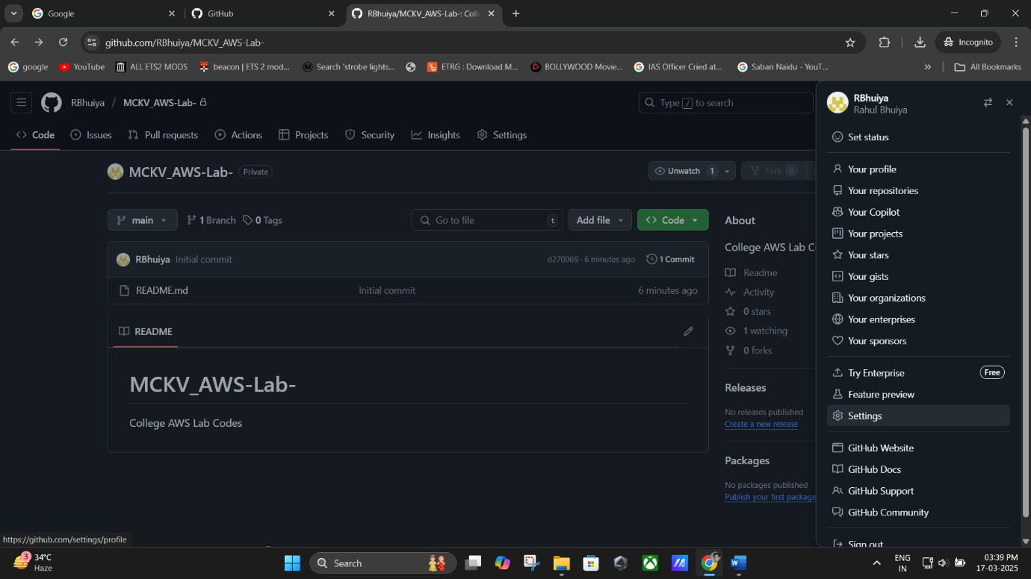

**(Click on your Profile Name → Settings).**

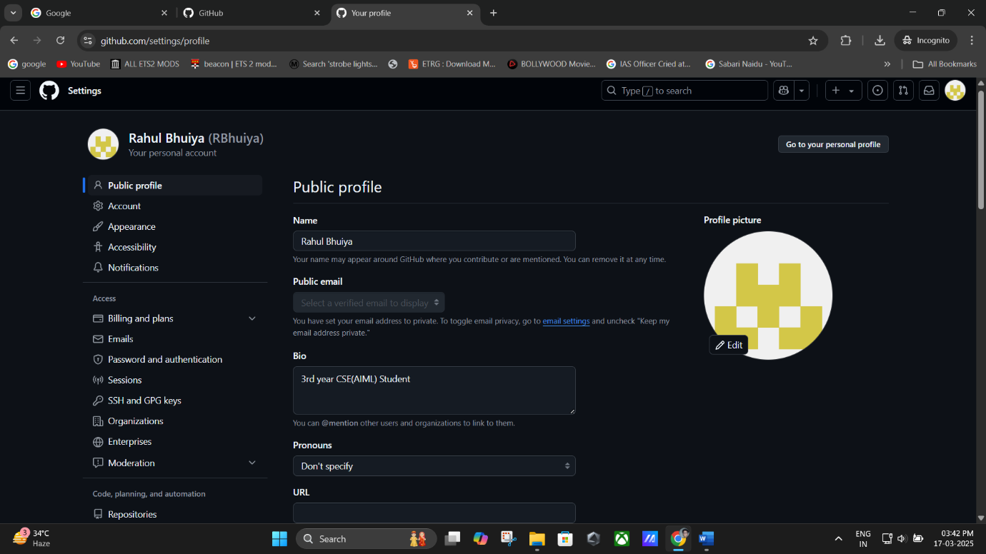

**(Settings Page).**

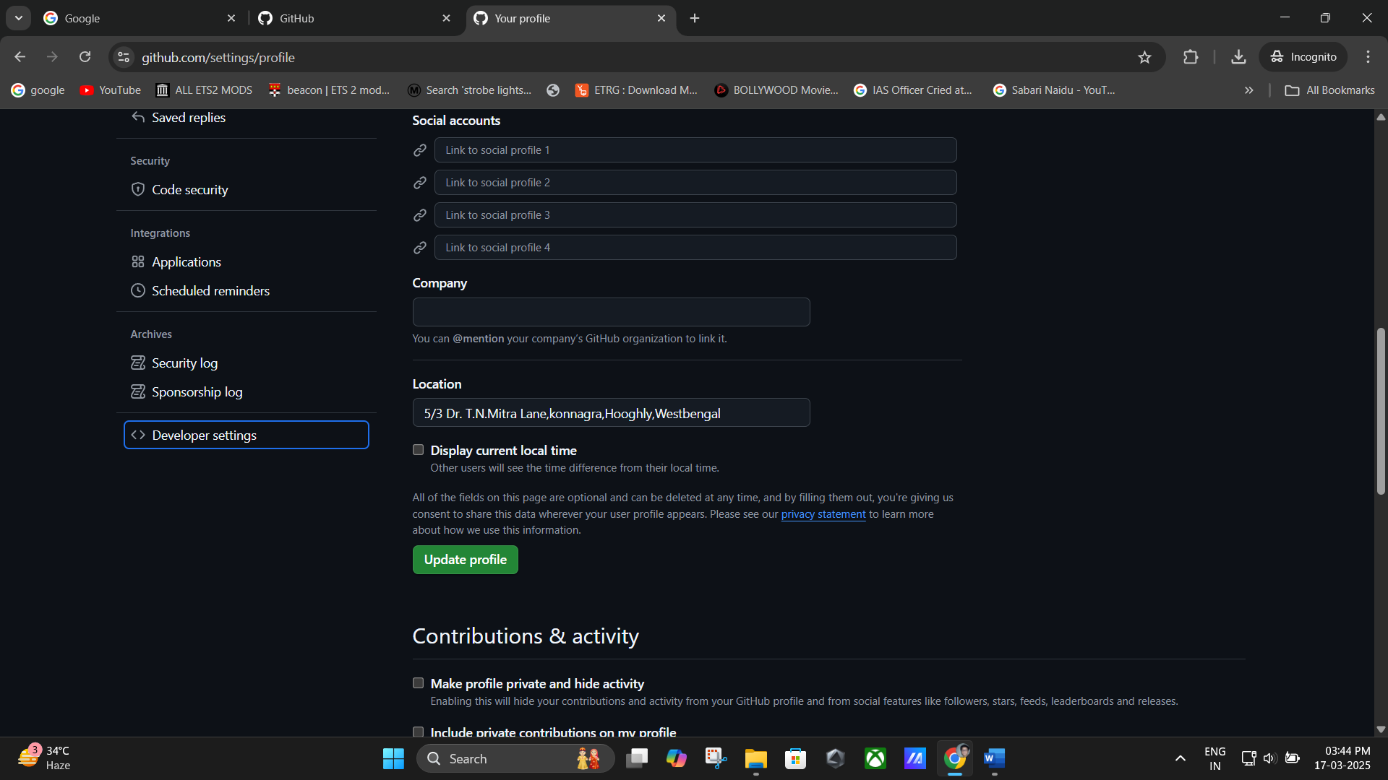

(Go to **Developer Settings** (left sidebar)).

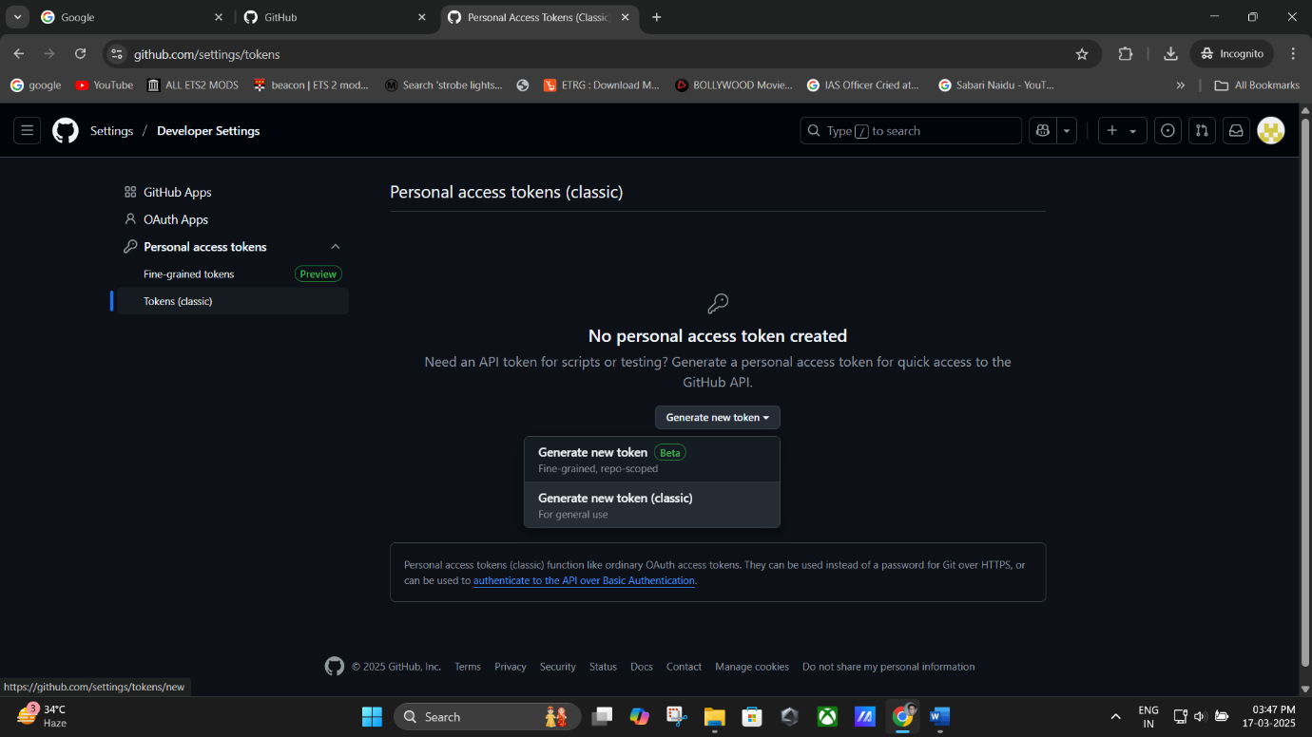

**(Click Tokens (Classic) → Generate New Token (Classic)).**

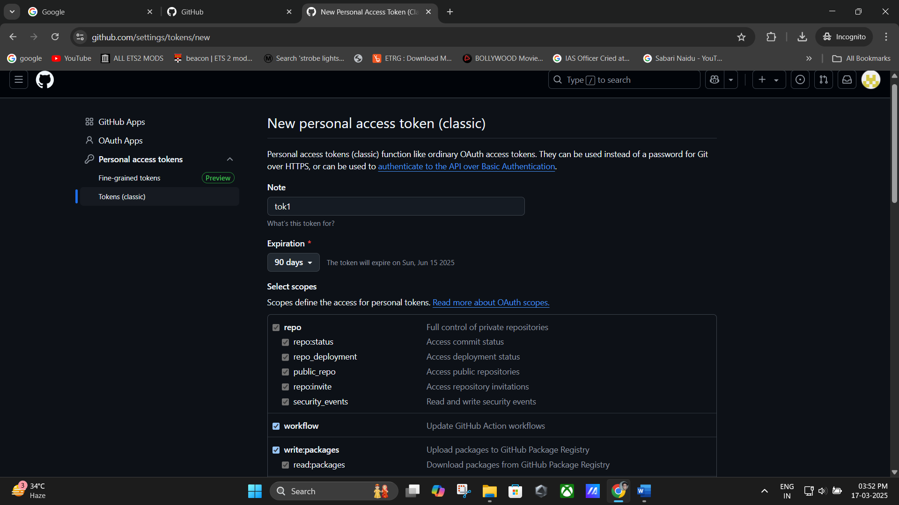

(**Token Name** (e.g., tok1) -> **Expiration Period** (e.g., 90 days) -> ✅ **all required permissions**).

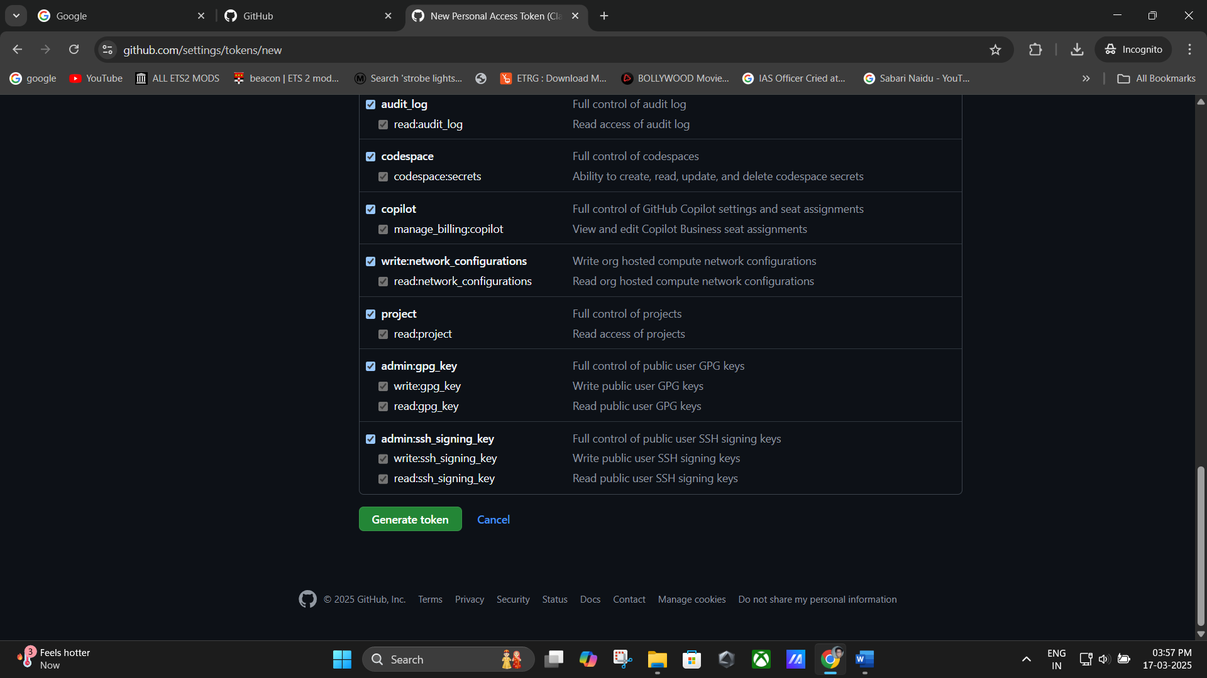

(Click **Generate Token** and **Copy the Token** for later use.)

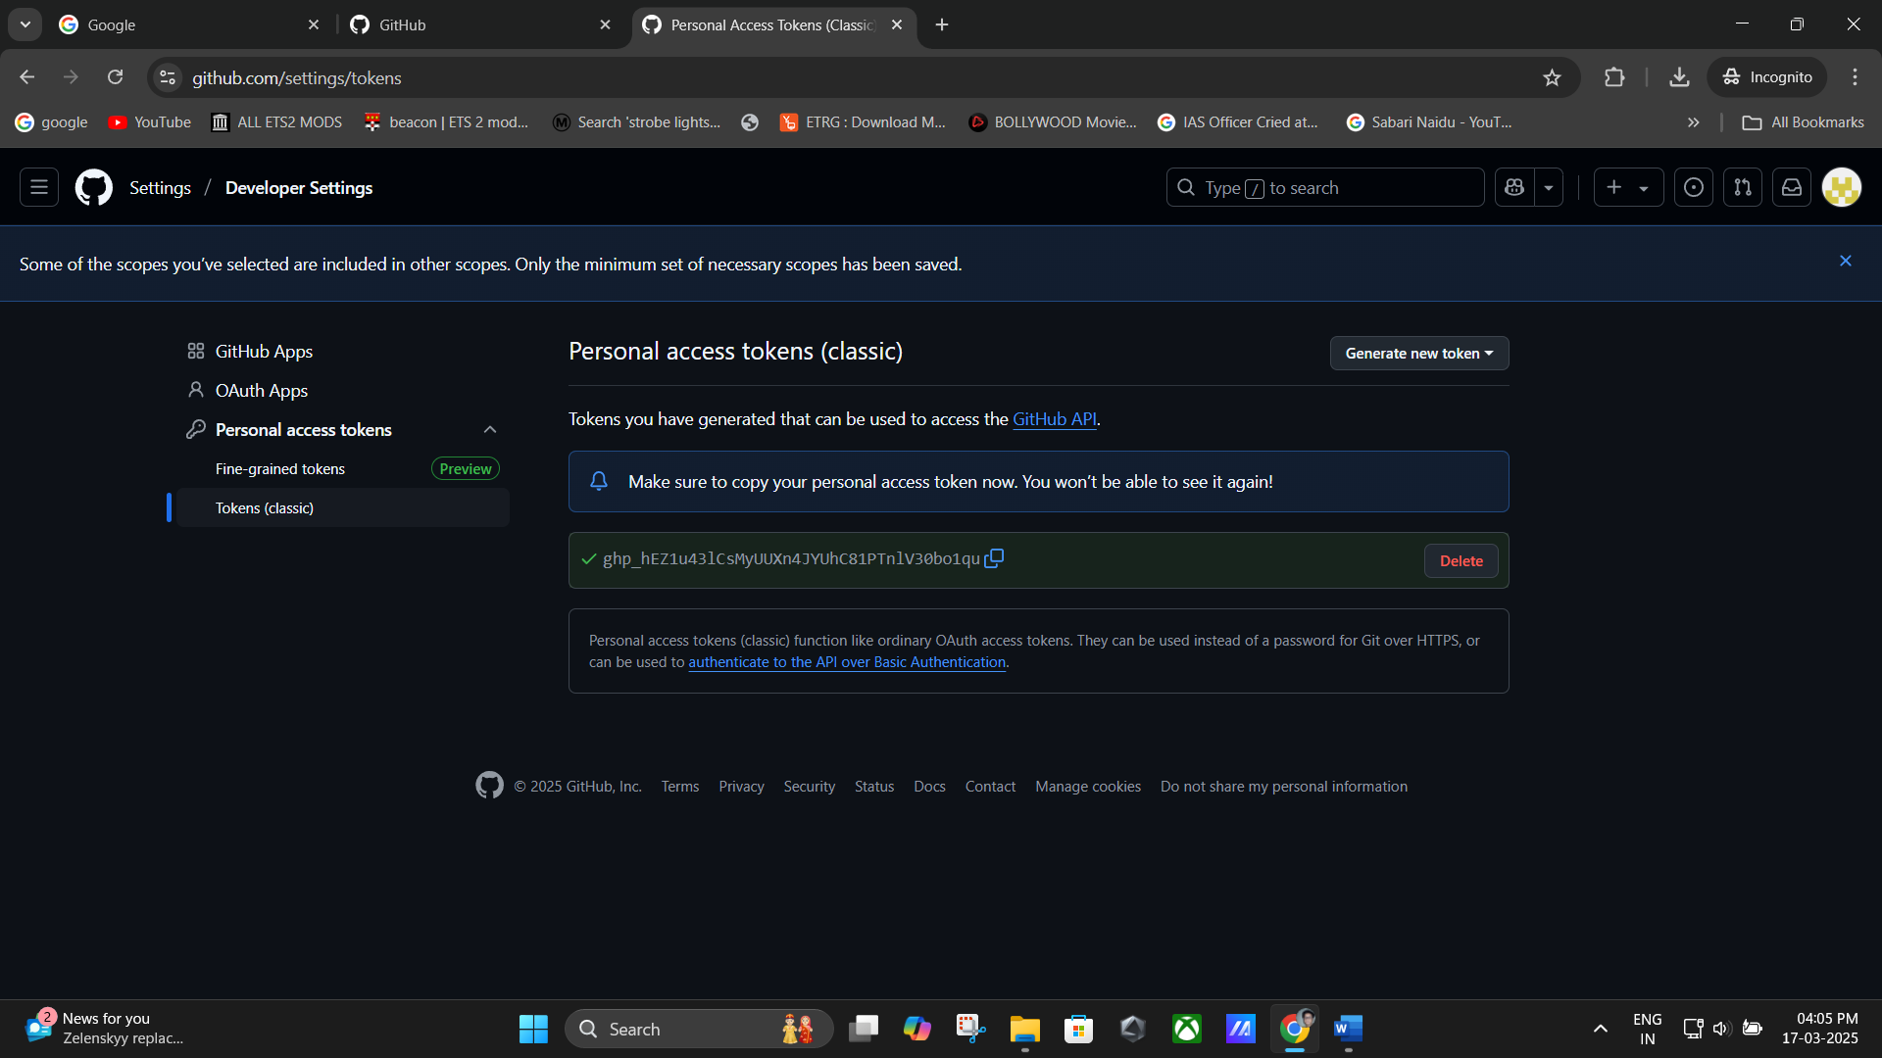

**(Copy the Token for later use).**

**Remark**: The token replaces your GitHub password for authentication when using Git.

# Step 3: Upload Files to GitHub Using Git Bash

## Prerequisites:

* + Install [**Git for Windows**](https://git-scm.com/downloads)if not already installed.

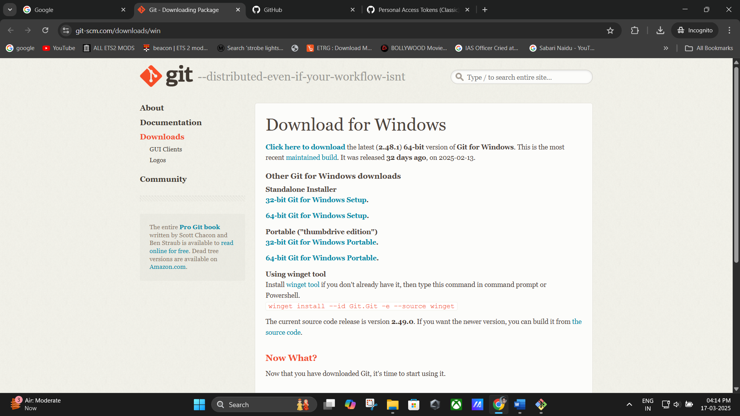

**(Download & install Git for windows).**

## Process:

### Navigate to Your Project Folder:

* + On your desktop, locate the folder containing project files.
  + **Right-click** inside the folder and select **Git Bash Here**.

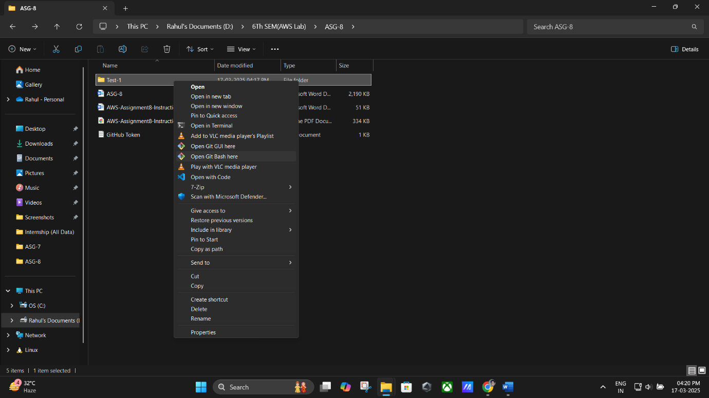

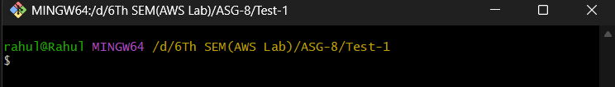

### Initialize Git in the Folder:

git init

* + This creates a new Git repository in the folder.

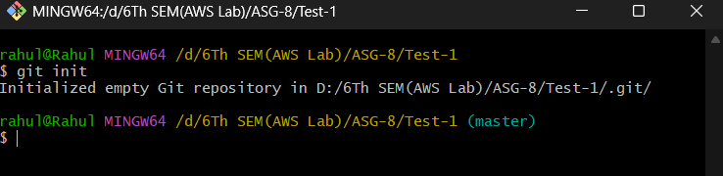

### Configure Git User Details:

git config --global user.email ["rahulbhuiya718@gmail.com"](mailto:%22rahulbhuiya718@gmail.com%22)

* + This links your local Git to your GitHub account.

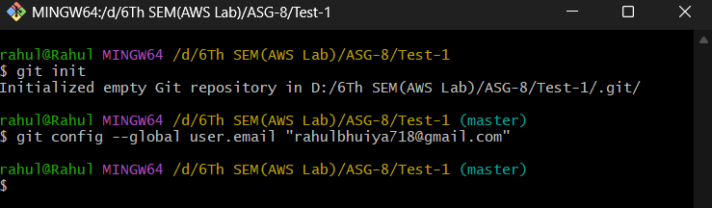

### Stage Files for Commit:

git add .

* + This adds all files in the folder to Git’s tracking system.

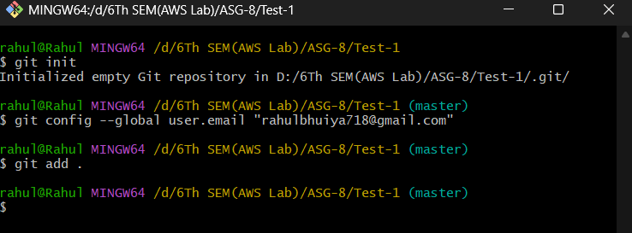

### Commit the Files with a Message:

git commit -m "Initial commit"

* + This saves the changes locally with a message.

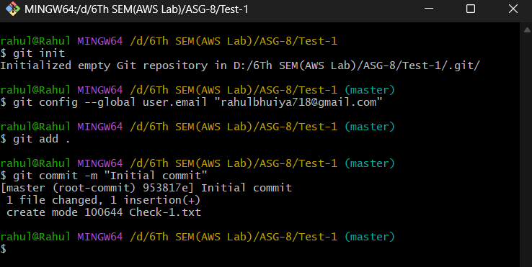

### Connect to the Remote Repository:

git remote add origin "https://github.com/RBhuiya/MCKV_AWS-Lab-.git"

* + This links your local repository to the GitHub repository.

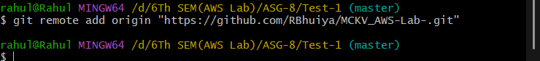

### Push the Files to GitHub:

git push -f origin master

* + A popup window appears asking for credentials.
  + Enter the **authentication token** instead of the password

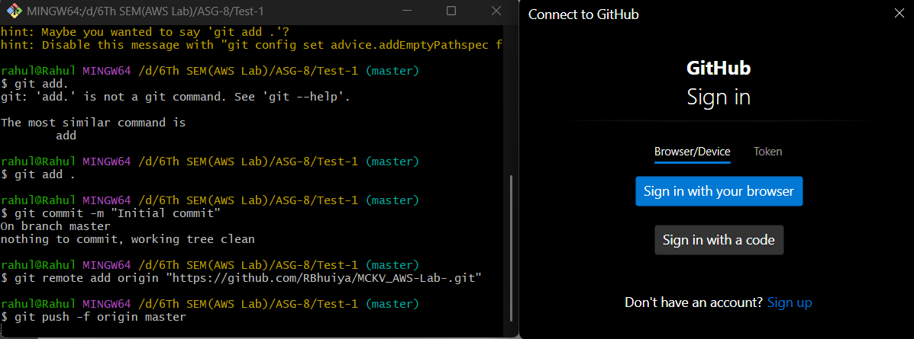

**(Pop up Window is appeared)**

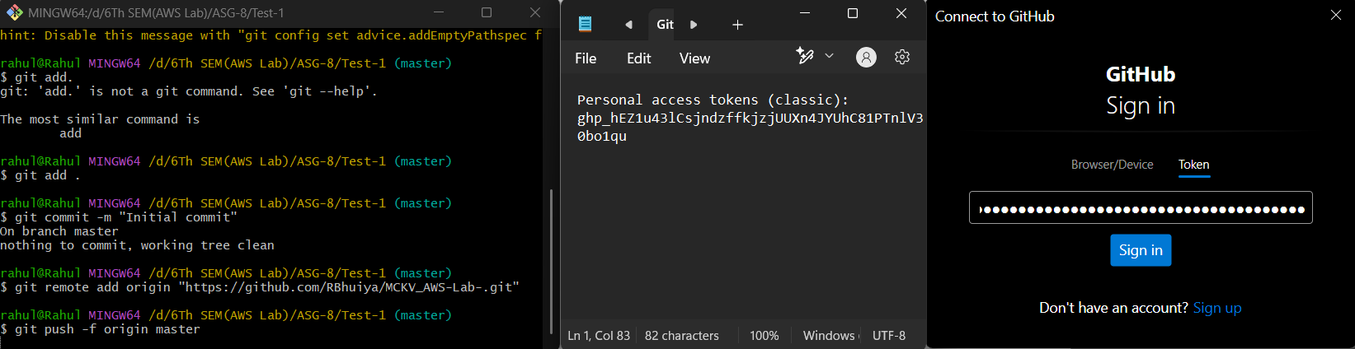

(Enter the **authentication token** instead of the password)

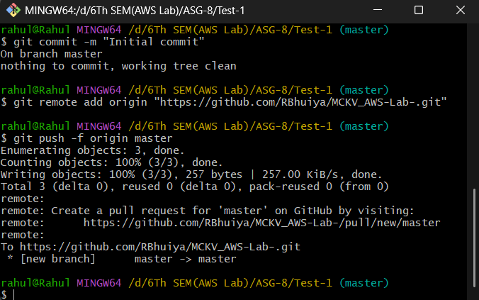

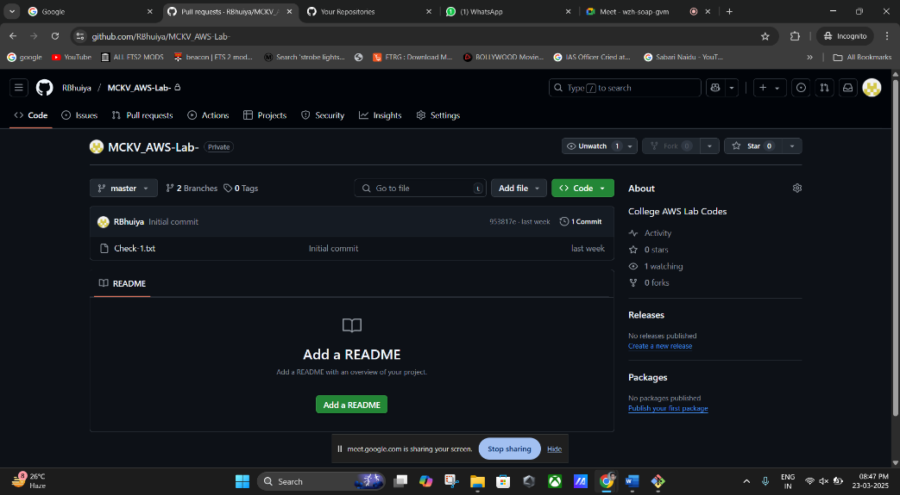

**Remark**: If successful, all files will be visible in the GitHub repository.

# Step 4: Clone a GitHub Repository to a Local Machine

## Scenario:

We want to download an existing repository (https://github.com/RBhuiya/MCKV_AWS-Lab-.git) to our local machine.

## Process:

1. **Create a New Folder** on your desktop (e.g., TestClone).

### Right-click the folder → Git Bash Here.

1. **Clone the GitHub Repository**:

git clone https://github.com/RBhuiya/MCKV_AWS-Lab-.git

* + This downloads the repository to the local machine.

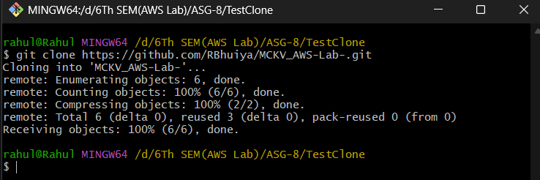

### Verify Files Are Downloaded:

ls

* + 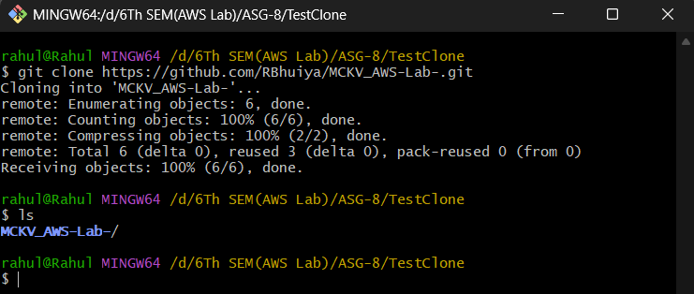This lists all files in the cloned repository.

### Navigate Inside the Cloned Repository:

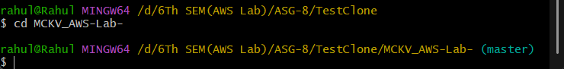cd New-Repo1

### Check Repository Files:

ls

* 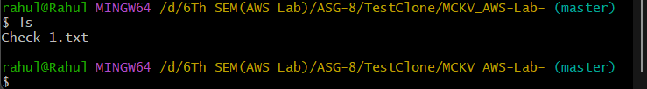This displays the files copied from GitHub.

**Remark**: You can now modify files and push updates back to GitHub using the steps from

**Step 3** (excluding token creation).

# Final Notes

* **Authentication tokens expire** after a set period; regenerate if needed.
* **Using git push -f overwrites changes** in the remote repository. Be cautious.
* **Ensure Git is installed** before attempting commands.
* **Use SSH authentication** instead of tokens for enhanced security.